**Application for Internship — Assignment Submission**

**Candidate:** SAHIL BHANDARI

**Introduction**

Dear Review Team,

I am excited for the opportunity to demonstrate my skills through this practical assignment. I have chosen a critical, routine problem in the Healthcare/Clinic department and delivered an automation solution using Google Sheets + Apps Script. This solution is designed with clarity, creativity, and technical rigor, and includes AI-enhanced logic to maximize efficiency while complying fully with assessment guidelines.

**1. Task Selection**

**Task Chosen:**  
Track Consumable Medical Supplies and Reorder

**Reason:**  
Effective tracking and timely reordering of consumable medical supplies is crucial in clinics but often done manually, leading to errors, wastage, or shortages. Automating this process boosts efficiency, ensures patient care standards, and minimizes staff workload.

**2. Problem Definition**

* **Current Situation:** Supplies are manually logged and checked; reordering is based on memory or periodic checks, risking stockouts.
* **Pain Points:** Human errors, missed reorders, inefficient time usage, lack of real-time visibility.
* **Stakeholders:** Clinic Manager, Nursing Staff, Receptionists, Patients.
* **Success Metrics:**
  + 0 supply stockouts per month
  + 90% reduction in manual log time
  + 100% on-time reorder notifications

**3. Solution Overview**

Google Sheets + Apps Script Automation: “Smart Supply Tracker & Reorder Alert”

**Features:**

* **Inventory Master Sheet:** Log all routine supplies, current quantity, and reorder threshold.
* **Daily Use Log:** Simple interface for staff to deduct consumed supplies.
* **Automated Stock Monitor:**
  + Apps Script checks stock levels daily.
  + When a supply falls below the reorder level, an automated email alert is sent to the Vendor and a confirmation email to Clinic Manager, including reorder details.
* **Reorder History Sheet:** Timeline of stockouts, reorder actions, and resolution times.
* **AI-enabled Predictions:**
  + Use of Gemini’s free-tier API to analyse monthly trends and predict which supplies are likely to run low next month.
  + Included a local validation routine with regex to check for data entry errors and flags inconsistent or negative quantities for review.

**4. Implementation Snapshots**

**a) Google Sheet (Demo Data)**

* **Sheets Included:**
  + Inventory Master

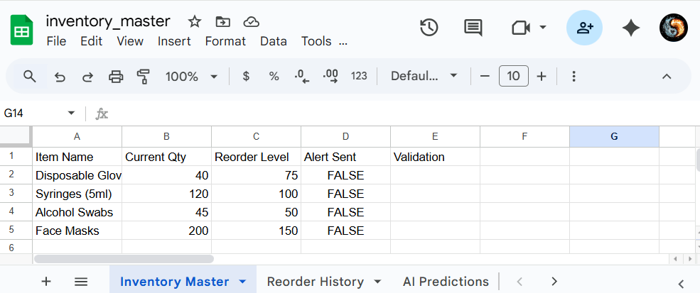

* + Usage Log

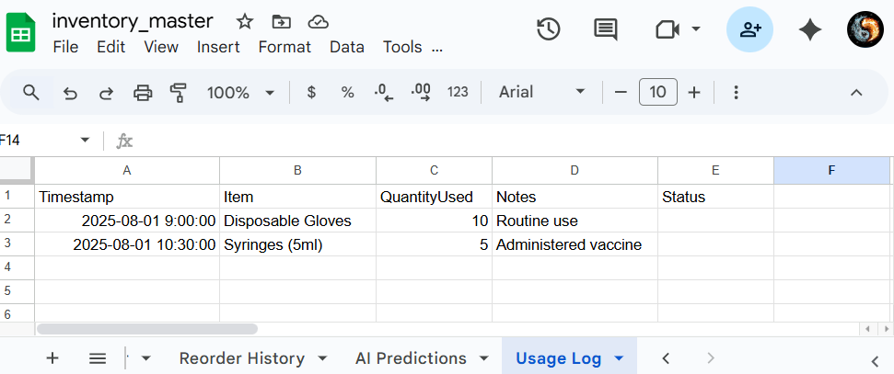

* + Reorder History

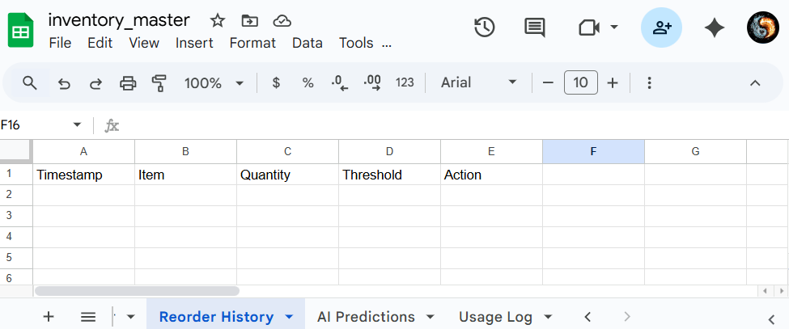

* + AI Predictions

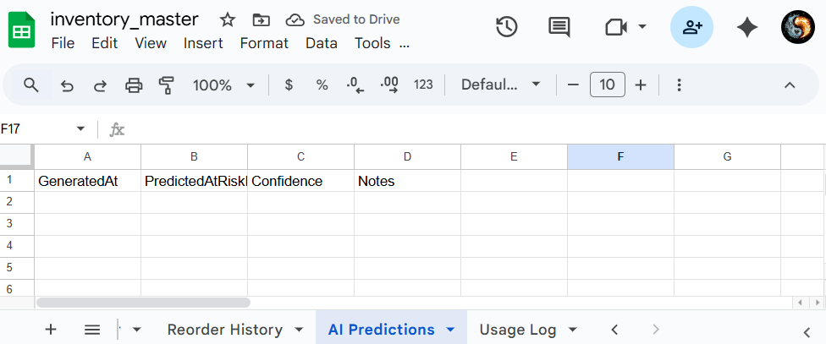

**b) Apps Script (Code Snippet)**

Reference for snapshot of code and app script code in a text format (apps_script.js file is also attached)



[Double click to open]

**c) Sample Output**

* **Running intialSetup():** Creates missing sheets if any and sets up triggers.

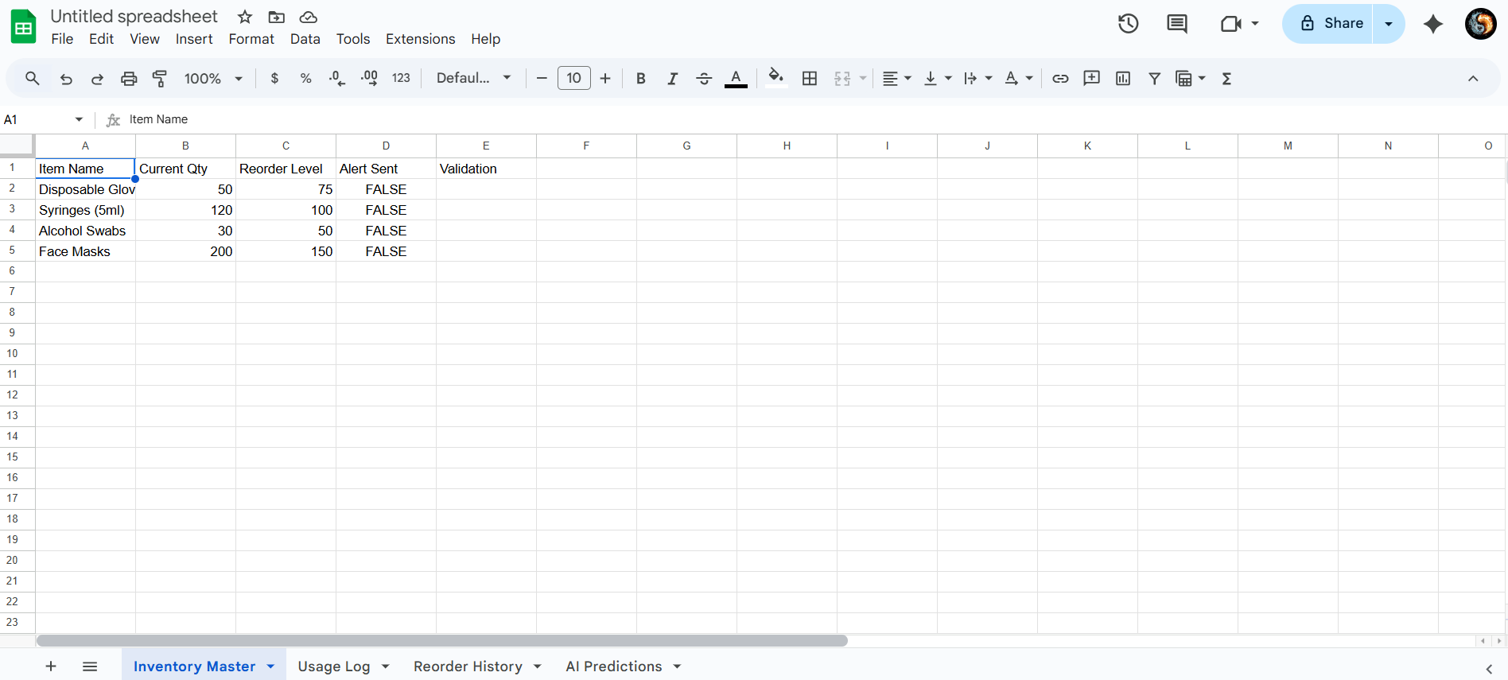

All four sheets will be created if anyone is missing. You have to manually put data into the sheets.

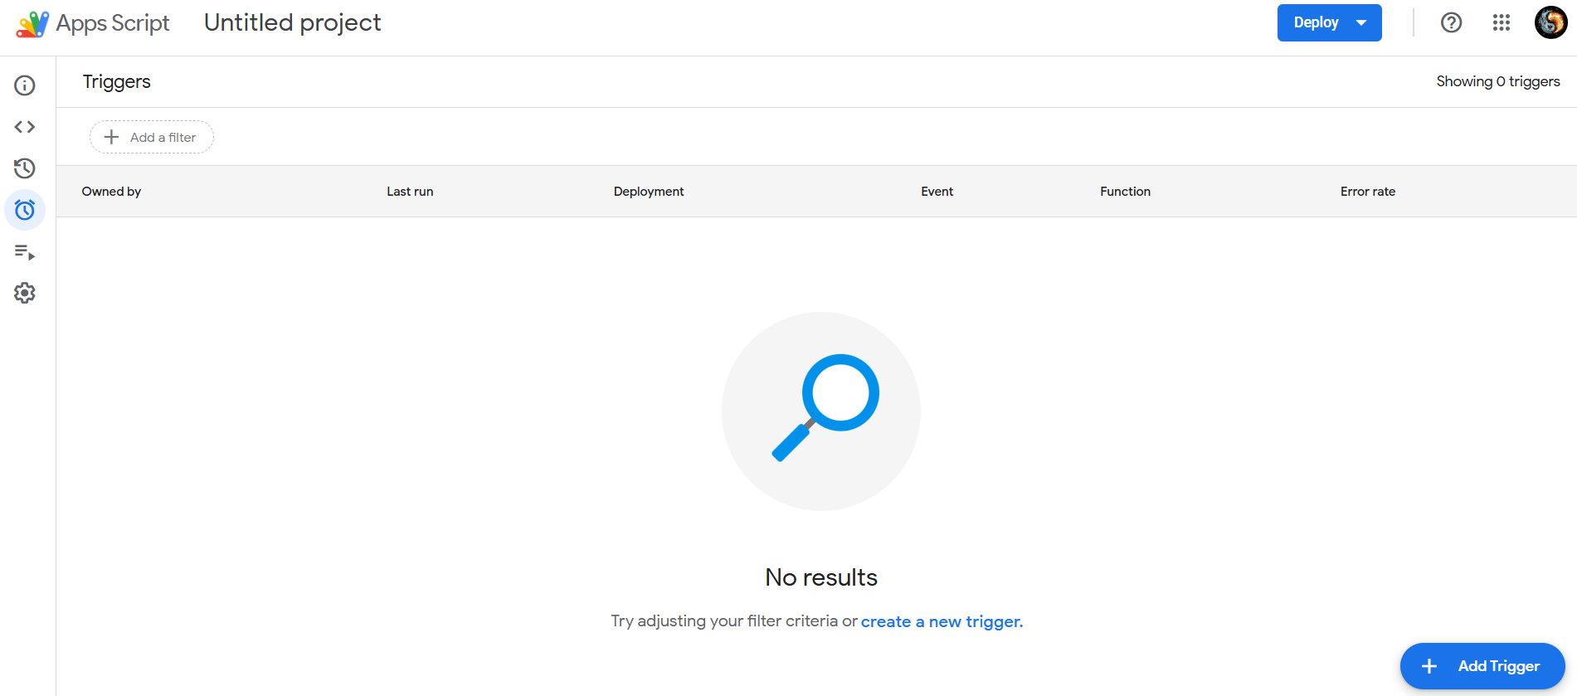

Triggers Before running initialSetup()

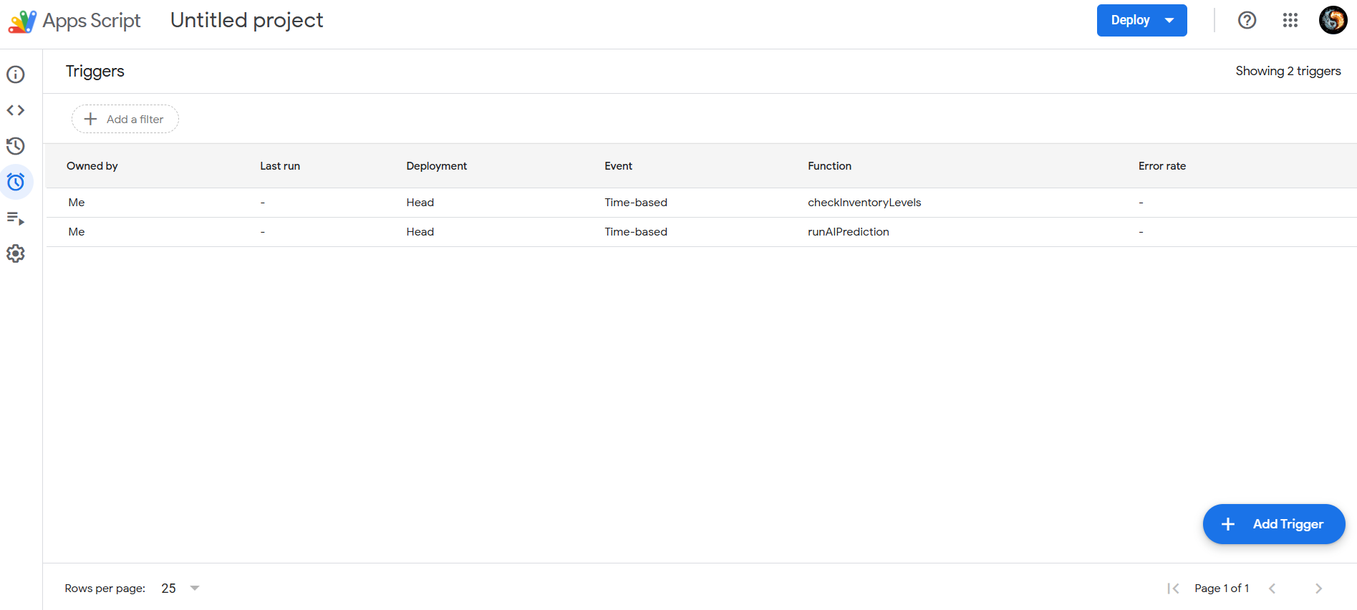

Triggers after (Creation of checkInventoryLevels and runAIPredictions)

* **Running applyUsageLog():** Deducts quantities from inventory based on Usage Log entries.

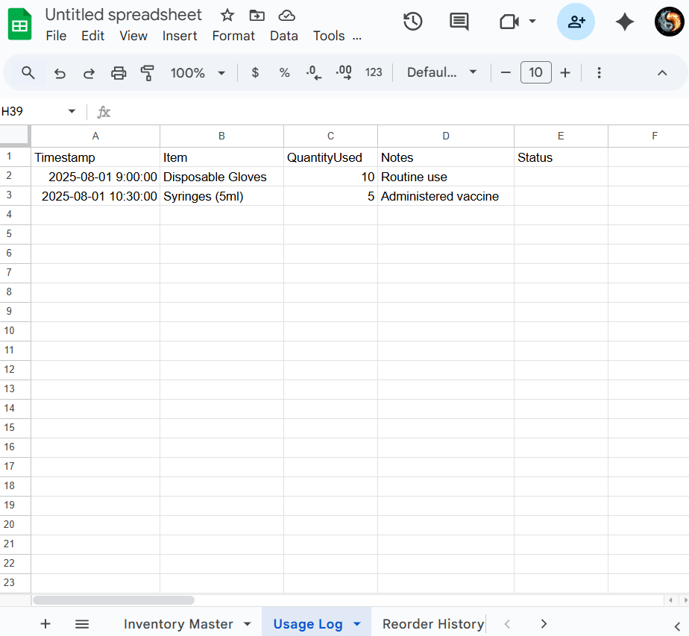

Usage Log Before

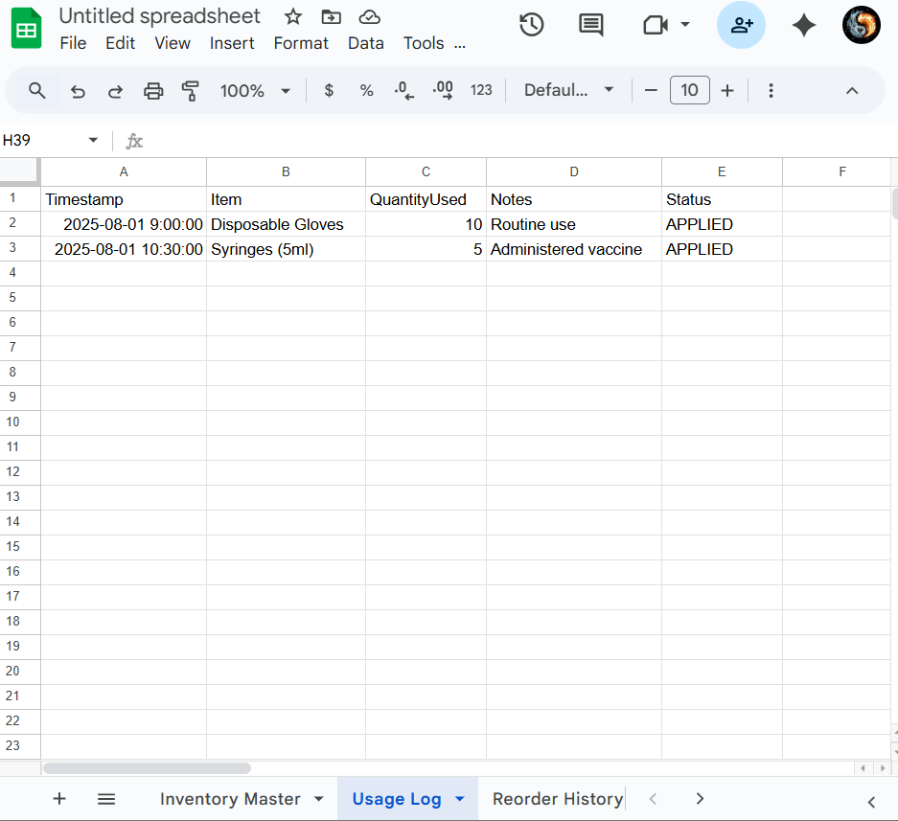

Usage Log After (Status updated as Applied)

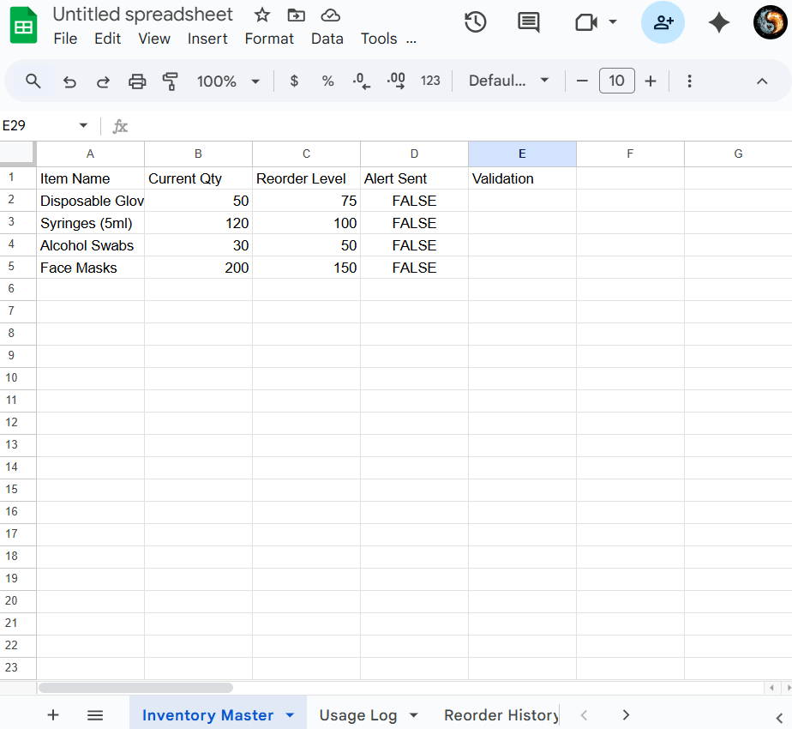

Inventory Before

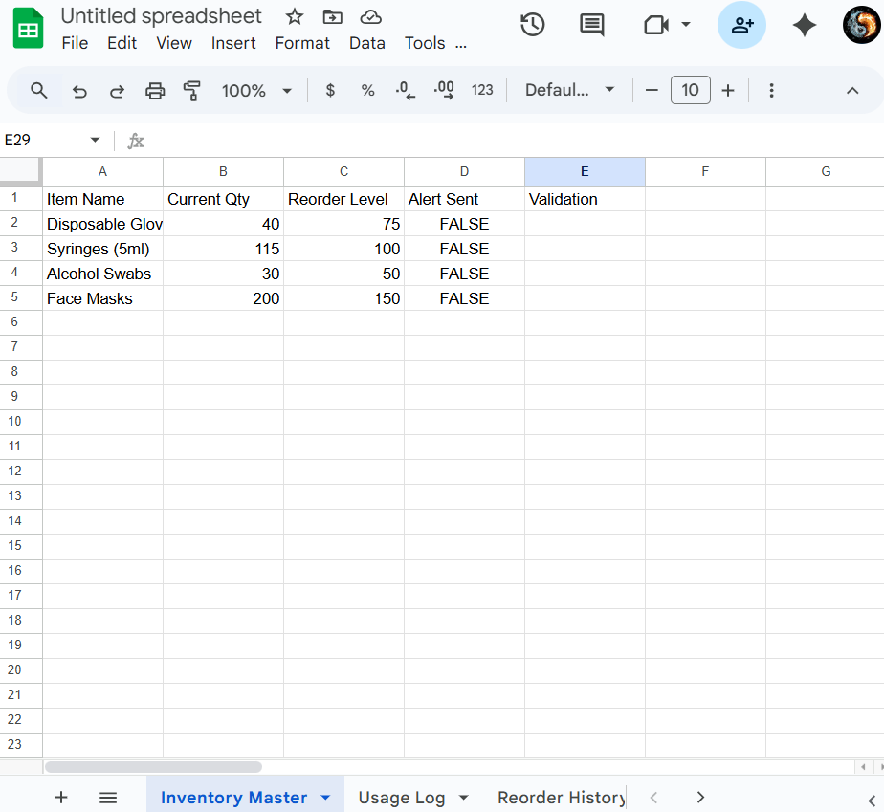

Inventory after (Applying usage logs data to main data resulting reduction in quantity)

* **Running checkInventoryLevels():** Runs daily, sends reorder alerts if stock ≤ threshold.



Inventory before

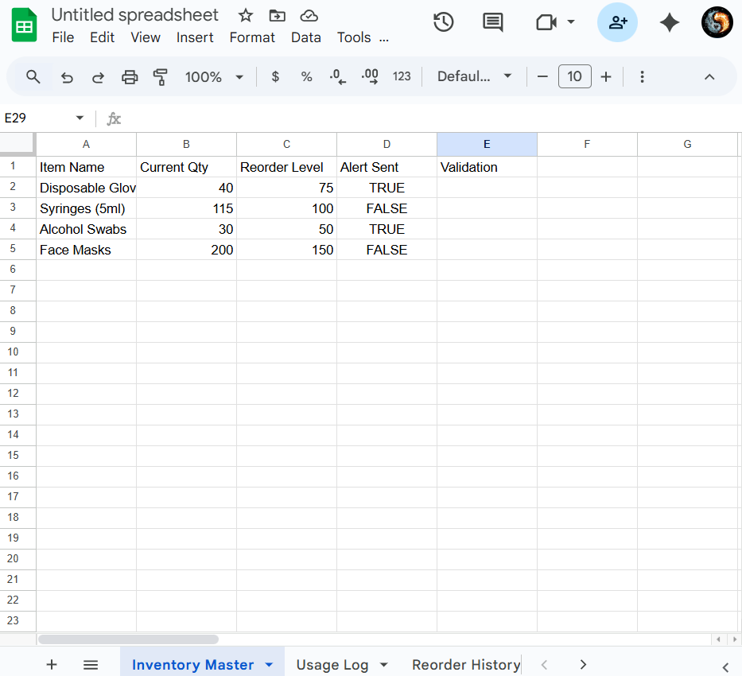

Inventory after (alert sent updated to true for less quantity item)

* **Running sendReorderAlert():** Sends an email to the Vendor for restock alert and a confirmation email to Owner.  
  + Reorder Email to Vendor (Sample):

*Subject: Restock Request: Disposable Gloves  
Body:*

*Dear Vendor,  
Please arrange for a restock of the following product:  
  
Item: Disposable Gloves  
Current Stock: 35  
Threshold: 75  
  
Kindly confirm the expected delivery date.  
--  
Automated Supply Tracker*

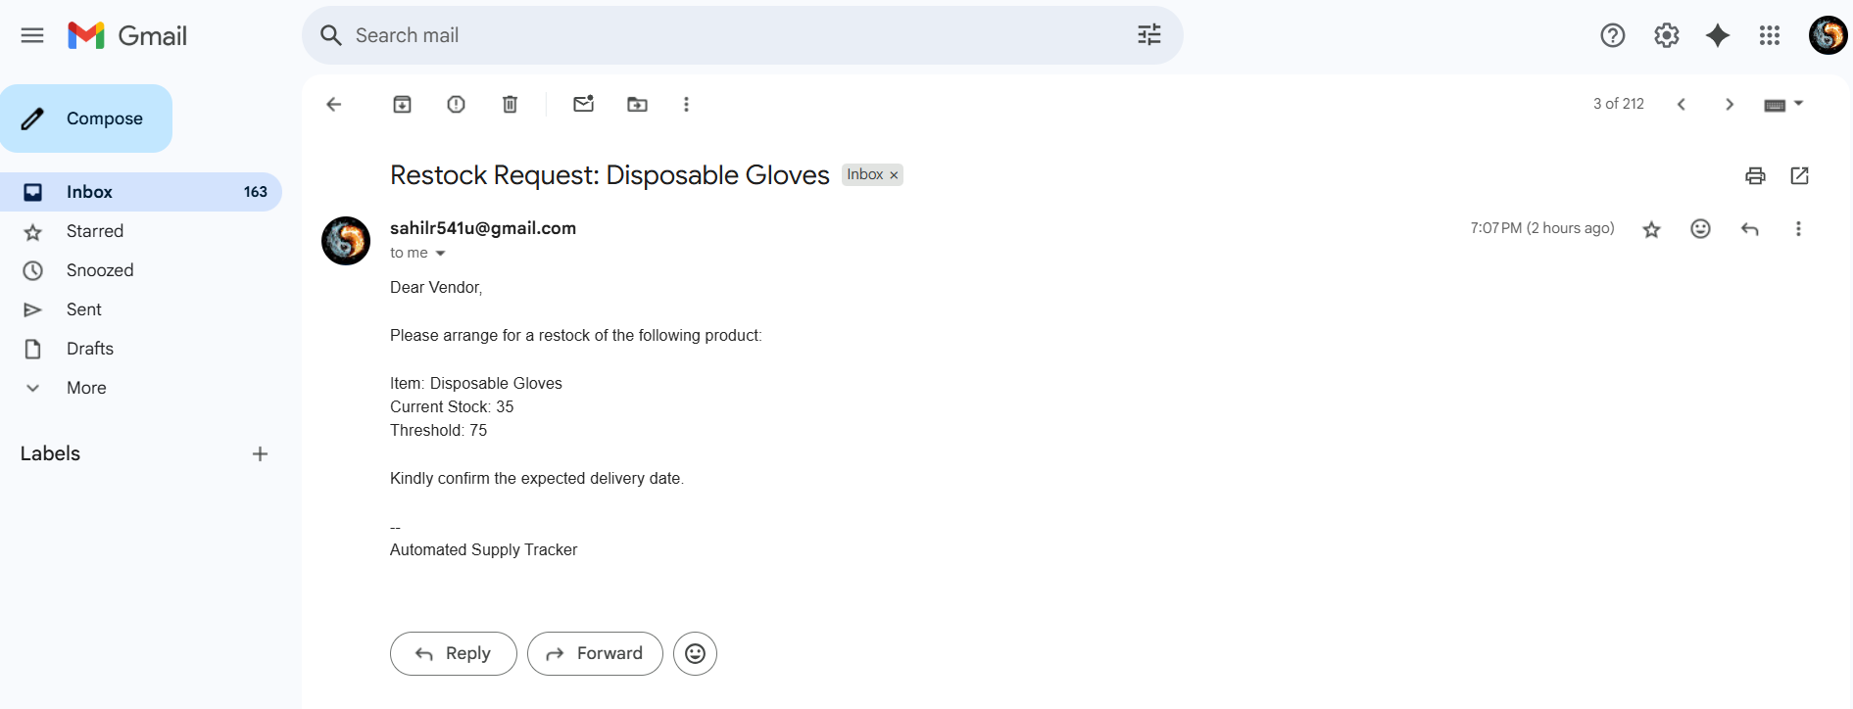

* Confirmation Email to Owner (Sample):

*Subject: Reorder Alert Sent to Vendor: Disposable Gloves  
Body:*

*This is to confirm that a reorder request has been sent to the vendor for:*

*Item: Disposable Gloves  
Current Stock: 35  
Threshold: 75  
  
The vendor has been notified to restock.  
--  
Automated Supply Tracker*

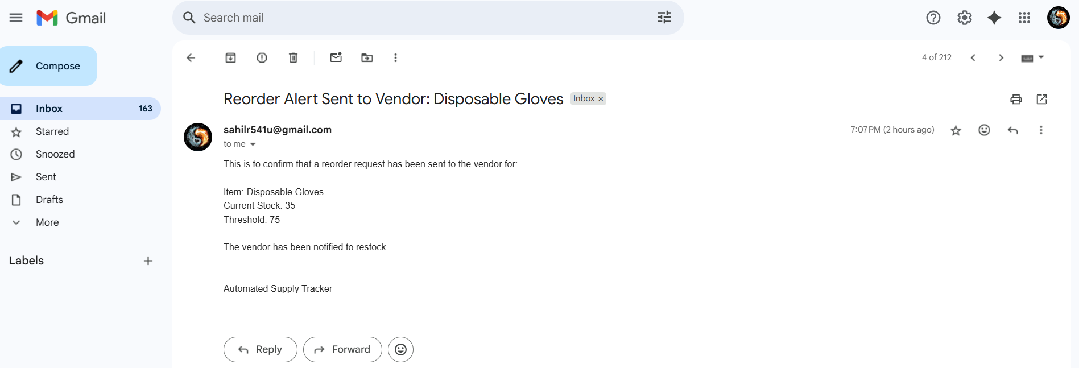

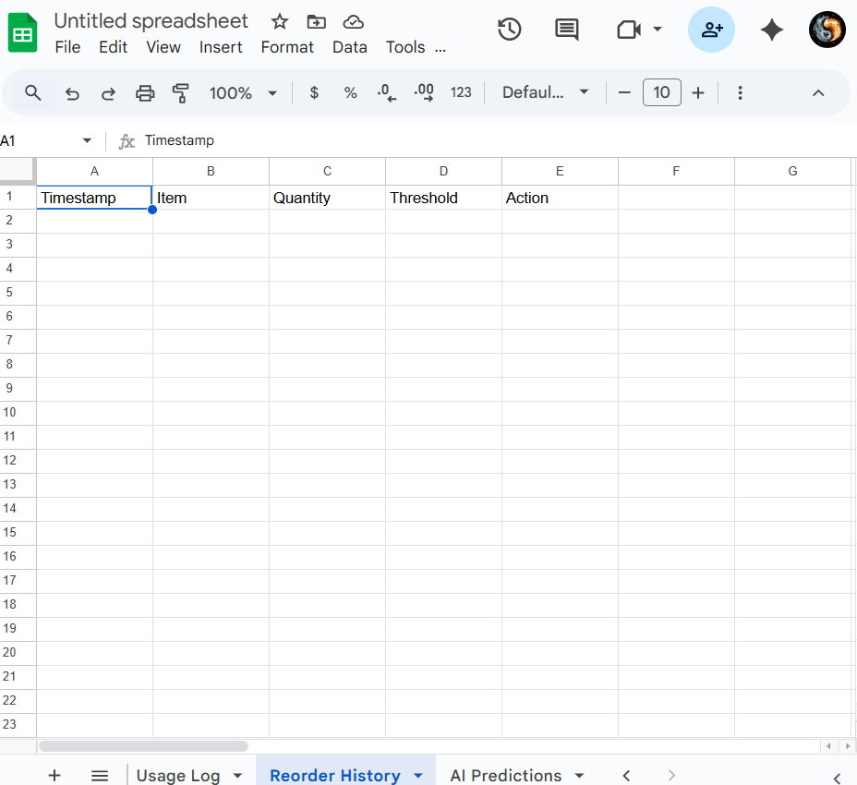

Reorder History Before

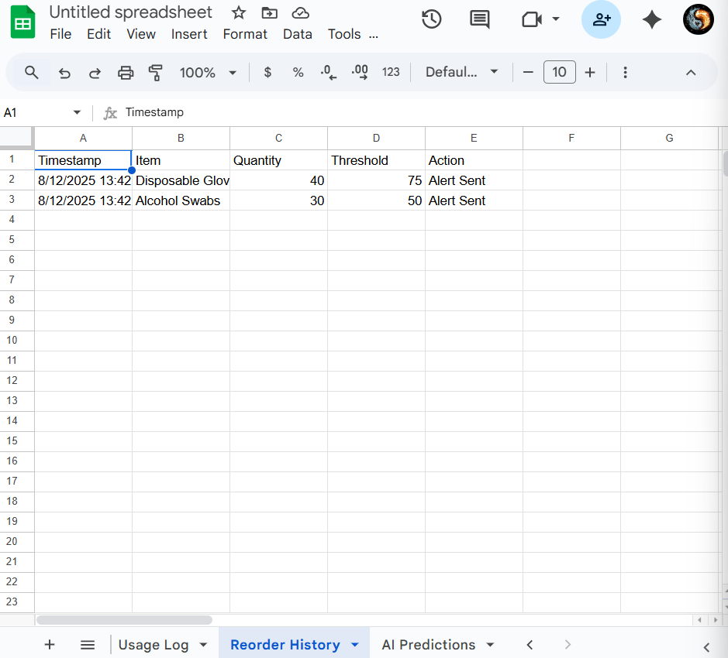Reorder History After (new details are added with action as alert sent)

* **Running runAIPredictions():** Adds AI predictions to AI Predictions sheet.

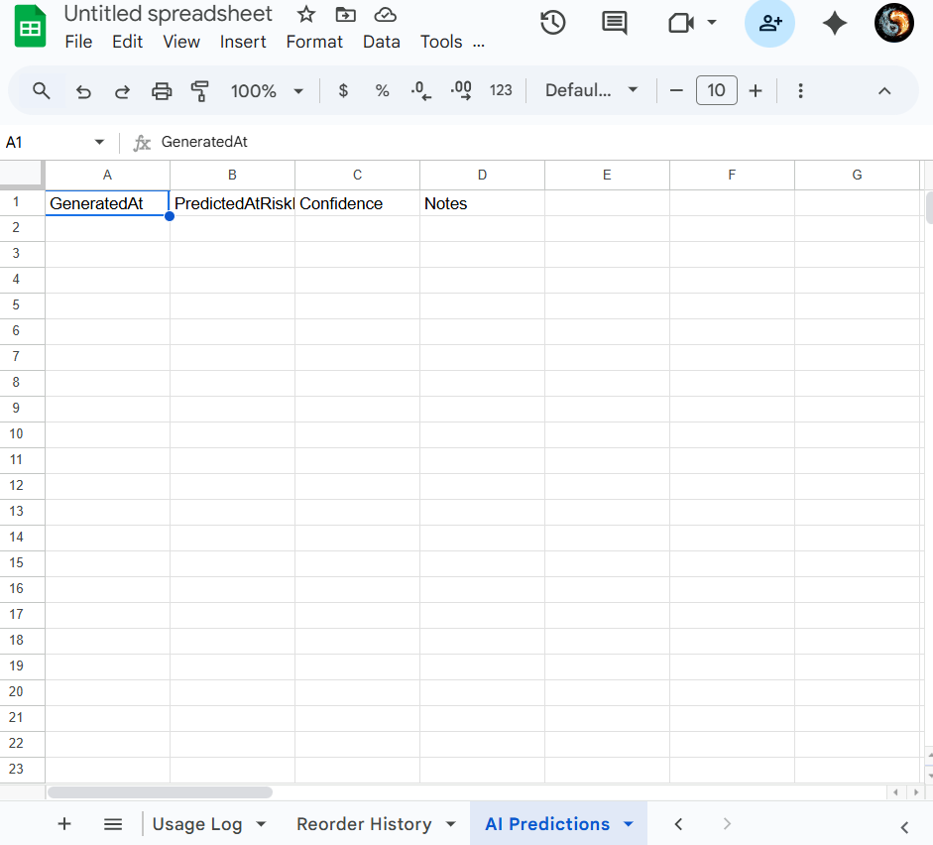

AI Predictions Before

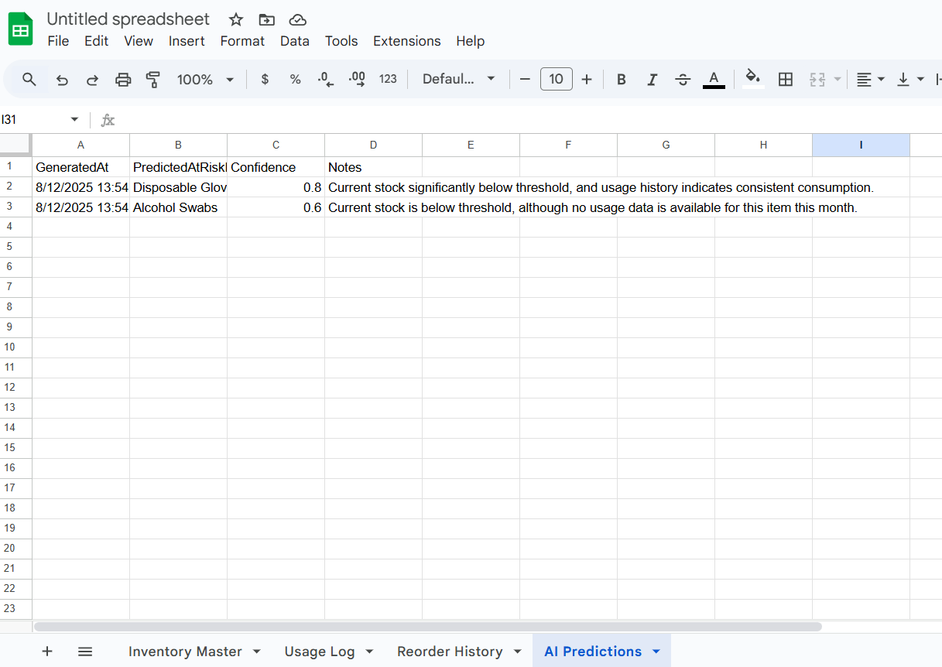

AI Predictions After (new added entries with AI generated content showing predictions)

**5. AI Disclosure**

* **Model:** Gemini Pro Free Plan, used for trend prediction and email draft suggestions.
* **Validation:** Sampled Gemini outputs for accuracy, regex checks in Scripts.
* **AI Prompt Used:** See README appendix (Attached).
* **Correction Routine:** Human-in-the-loop review for model anomalies and flagged entries.

**6. Extra Credit: Local Validation Routine**

* **Regex Checks:** Scripts reject negative values, non-integer quantities; flags “impossible” trends for manual review.
* **Human Sampling:** Weekly staff spot-check of AI flagged anomalies.

**7. Conclusion**

This solution transforms a tedious, error-prone clinic operation into an automated, AI-augmented process that directly improves care, staff satisfaction, and productivity. I have demonstrated an end-to-end implementation with practical validation and explainable use of AI. I am confident this reflects my readiness and drive to excel in your internship program.

Thank you for your consideration.

**Attachments:**

* Google Sheet (demo with data)
* Apps Script (javascript file)
* README with AI Appendix, instructions & prompt
* Sample output files

*(All sensitive details anonymized; API keys as placeholders with reviewer instructions included.)*